EXPERIMENT:7

**Practice Queries using ANY, ALL, IN, EXISTS, UNION Set Operators**

ANY:

**SELECT num_value, name FROM table1**

**WHERE num_value > ANY (SELECT num_val FROM table2);**

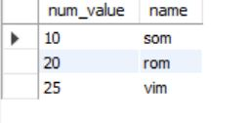

**ALL :**

**SELECT num_value, name FROM table1**

**WHERE num_value > ALL (SELECT num_val FROM table2);**

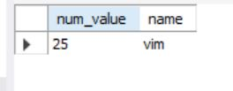

CREATE TABLE table1 (num_value int,name varchar(20), occupation varchar(20), age varchar(20));

INSERT INTO table1 values (101, 'Peter', 'Engineer', 32);

INSERT INTO table1 values (102, 'Joseph', 'Developer', 30);

INSERT INTO table1 values (103, 'John', 'Leader', 28);

INSERT INTO table1 values (104, 'Stephen', 'Scientist', 45);

INSERT INTO table1 values (105, 'Suzi', 'Carpenter', 26);

INSERT INTO table1 values (106, 'Bob', 'Actor', 25);

CREATE TABLE table2(order_id int , cust_id int, prod_name varchar(45),order_date date);

INSERT INTO table2 values (1, '101', 'Laptop', '2020-01-10');

INSERT INTO table2 values (2, '103', 'Desktop', '2020-02-12');

INSERT INTO table2 values (4, '104', 'Mobile', '2020-03-05');

INSERT INTO table2 values (5, '102', 'TV', '2020-03-20');

**EXISTS:**

SELECT name, occupation FROM table1

WHERE EXISTS (SELECT * FROM table2

WHERE cust_id = table2.cust_id);

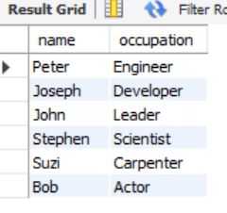

**IN:**

select num_value, name, occupation from table1 where age in(25,26,28) order by age;

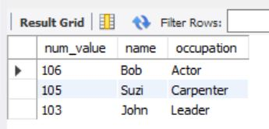

UNION:

select * from table1 union select * from table2;

